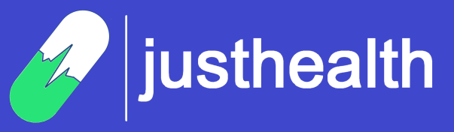

|  |
| --- |
| [Version 1.0]  **Last saved by: Ben McGregor**  **Last saved on:** 12/10/2014 |
|  |

|  |
| --- |
| Logo Design and Branding |
| 01/10/2014 |
| **Ben McGregor**  CO600: JustHealth Supervisor: Yang He |

# Product Name

There are different factors to consider when choosing a name for an application; it needs to be eye catching, easy to remember and encapsulate the primary purpose.

The names put forward included ideas such as:

* eCare/e-care/e-carer
* HUKI (Healthy and you know it)
* eDoctor
* Medicare
* **JustHealth**
* JustCare
* SimpleCare
* EasyDoctor
* Take it easy
* Medicapp

The group united on JustHealth after discussing each idea.

# Logo and branding

There are presently over 31,000 applications on the market that fall into the health & fitness bracket; an industry that is estimated to be worth over $600 million. Although these are unregulated and can be giving misleading information, there is an obvious need to stand out from the market and be unique. Market research when attempting to design for your company has to be done slightly differently, it is very hard for the brain to differentiate from images you have already seen, which

Whilst researching branding, it was noticeable that there were a number of factors to take into account.

* Colours
* Fonts
* Pictures (Logo)
* Size
* Letter spacing
* Capitalisation

After a few hours with a sketchpad, discussing aesthetics of logos and designing an image to brand JustHealth with, we had an initial design to build on. By making general observations of brands used in daily life, and also researching other successful companies, we decided it was important to have a logo that included the company name in a simplistic, memorable font. Other important features were the colour choices and also having an image to separate from the main logo that could be used alone to identify the brand by; this is also important with an application so there is a logo for the icon.

### Colours:

There are many elements of the logo that could be chosen to be coloured. However, after some market research, it became obvious that successful companies use a maximum of 3 colours. Google are one of the rare instances where more than 3 colours have been used and they have successfully gained worldwide recognition with those colours.

After experimenting with different colours and looking at positive/negative associations, we have settled on an initial design involving variations of blue.

**Blue:** many healthcare companies use blue, so there is a lot of competition; positive association with the colour of hospital uniforms.

**Red:** common association with blood, not the primary focus of our application and want to avoid distraction from the purpose.

**Yellow:** difficult to find complimentary colours to fit with it, negative connotations with many illnesses.

**Green:**  ‘Go’, encouraging, positive connotations; negative in terms of illnesses.

We decided to keep black away from the logo as white text seemed to be slightly more distinctive on the dark blue background.

### Font

We tried to keep a simplistic, Sans-serif font that would be both easy to replicate and eye catching.

 



Figure 1: Font ideas

The final version uses ‘Miriam’; as shown in red, it appears the most professional and easy to replicate for future use.

### Capitalisation

When deciding on a name for our application, we came up with JustHealth, but when designing a logo, the format in which the word is written can define whether it is successful.

The decision will have to be taken whether to adapt the text to one of the following:

* JustHealth
* Justhealth
* justhealth
* JUSTHEALTH



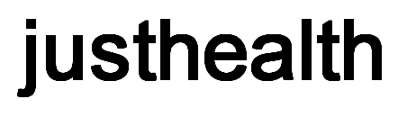

Figure 2: Text format ideas

We decided the most effective style of writing the name was ‘justhealth’; but agreed that any other documentation should maintain the style JustHealth. This may be difficult to enforce upon expansion but is the current plan.

### Image

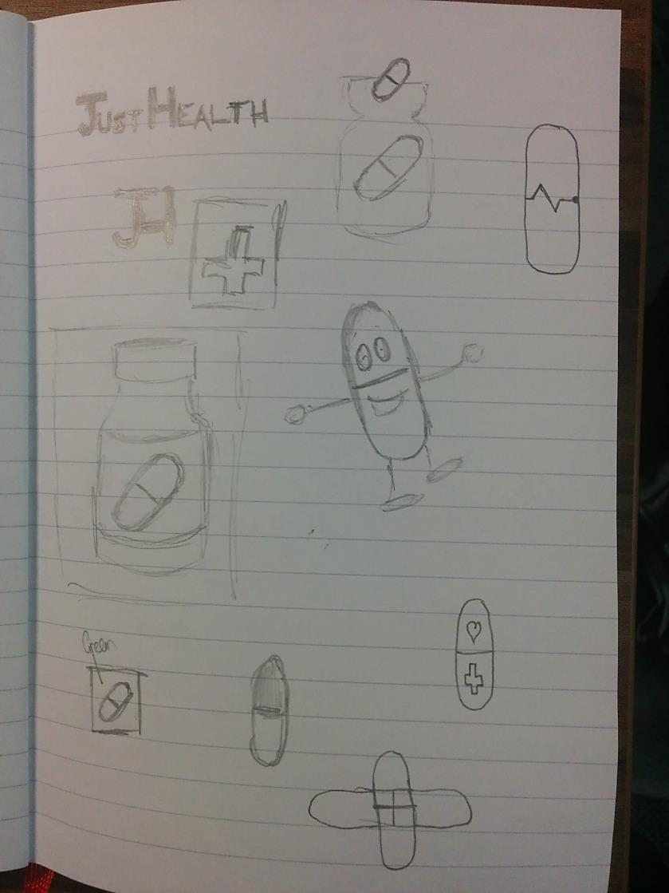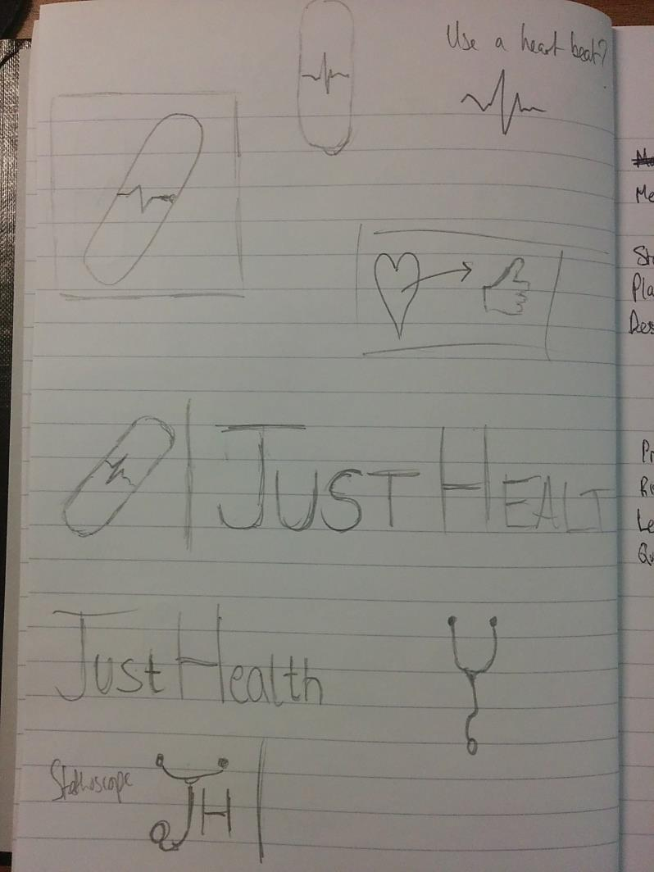We understood from market research that it was important to have an image that could be separated from ‘JustHealth’ in order to identify the brand with. The easiest way to do this was with a sketchpad, analyse and get feedback; then to digitise some of the results.

### Digitised images

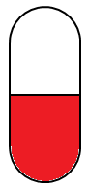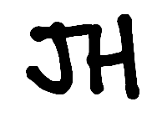 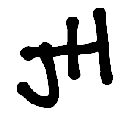 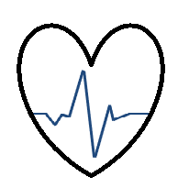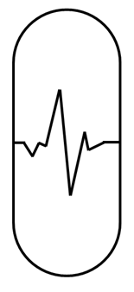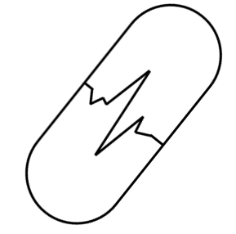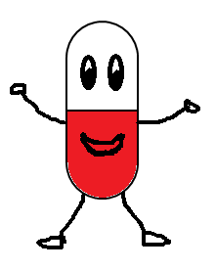Figure 3: Application icon ideas

Using an amalgomation of these images, along with the chosen colours, we managed to design a tablet, with the pulse of a heart beat providing the natural separation line, changing the colour of the half the tablet to the familiar hospital uniform (‘scrubs’).

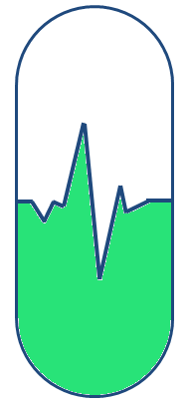

Figure 4: Chosen image for application icon

Combining all the features discussed above, including experimenting with colour schemes and different features, the final logo design to be used is:

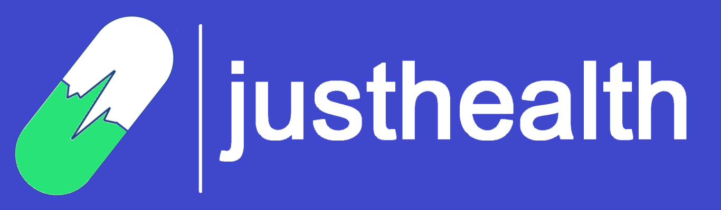

Figure : Final Logo Design

Final logo RGB colours:

*Background: R 63, G 72, B 204*

*Font: R 255, G 255, B 255*

*Image: R 40, G 227, B 120*